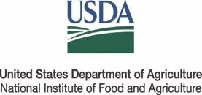



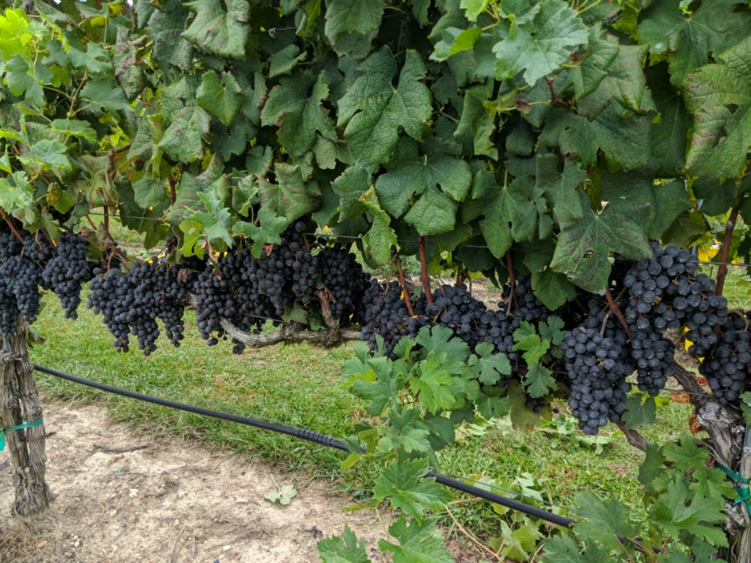

**Date:** March 11, 2021

**Time:** 8:00 am-12:00 pm

**Cost:** No Charge

**Eventbrite registration:** <https://www.eventbrite.com/...>

**Workshop Contacts:**

Henderson County | Karen Blaedow | Phone: 828-697-4891 & Email: [karen_blaedow@ncsu.edu](mailto:karen_blaedow@ncsu.edu)

Surry County | Joanna Radford | Phone: 336-401-8025 & Email: [joanna_radford@ncsu.edu](mailto:joanna_radford@ncsu.edu)

Wilkes County | Eli Snyder | Phone: 336-651-7333 & Email: [elina_snyder@ncsu.edu](mailto:elina_snyder@ncsu.edu)

Yadkin County | Hannah Lepsch | Phone: 336-849-7908 & Email: [hannah_lepsch@ncsu.edu](mailto:hannah_lepsch@ncsu.edu)

NCDA Pesticide Credits available for this workshop: 2 hours – N, O, X, D

**Join us for a virtual training and research update featuring N.C. State specialists**

**Vineyard managers:**

You are invited to join N.C. Cooperative Extension and N.C. State specialists for an online workshop for growers, industry partners and others involved in commercial grape production. This webinar will cover an overview current production and recent research pertinent North Carolina vineyards. This event will be held virtually via Zoom, and pre-registration is required.

**Topics covered will include:**

* Integrated pest management strategies for vineyards
* Sour rot concerns and management
* Optimizing spring/summer weed management
* Research and industry updates

**2021 Winter Vineyard Manager Workshop**

Ch

NC State University and N.C. A&T State University commit themselves to positive action to secure equal opportunity regardless of race, color, national origin, religion, political beliefs, family and marital status, sex, age, veteran status, sexual identity, genetic information or disability. NC State, N.C. A&T,

U.S. Department of Agriculture, and local governments cooperating.